BLUE MOUNTAINS QUILTERS COACH TRIP TO THE
CENTURY OF QUILTS EXHIBITION
National Gallery in Canberra – Friday 10 May 2024

Cost for BMQ members $50/hd which includes a private guided tour of the quilts

Leaving Lawson 6.30am and returning around 7pm
Picks ups down the mountains at
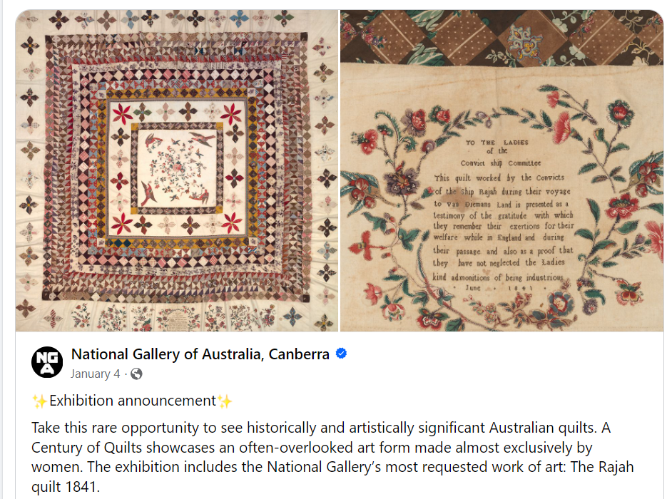
Faulconbridge and Blaxland Stations and Glenbrook Oval

